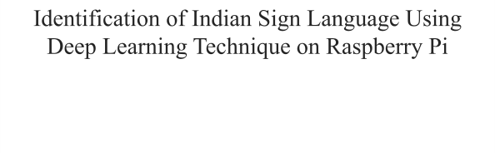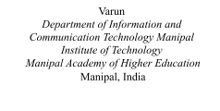identification is of significant smooth and reliable connection with the hardware. This
Abstract---
Real-time
object

importance across many industries, including sign languages, since it has the potential to optimise efficiency and accuracy in tasks such as object identification. This research introduces a novel methodology for real-time detection of Indian sign languages utilising the YOLOv5 model on a Raspberry Pi platform. A thorough dataset of Indian sign languages was collected and compiled, wherein the sign languages were categorised into several categories based on their sign characteristics. The YOLOv5 model underwent training using the provided dataset, and data preprocessing was conducted to optimise precision accuracy to its highest potential. Subsequently, the model was implemented on the Raspberry Pi, considering the limitations imposed by the hardware. The model was optimised for the processing resources of the Raspberry Pi by implementing quantization techniques, resulting in improved efficiency for real-time inference. By conducting thorough experimentation and evaluation, the study provides evidence of the efficacy of the proposed methodology, which enables real-time object detection to identify the Indian sign language on the Raspberry Pi platform. The proposed solution exhibits the potential to bring about a revolutionary transformation in sign language processing and enhance sign language identification comprehensively. This is achieved via the provision of a tool that is both cost-effective and efficient for the purpose of object-detecting duties.
I. INTRODUCTION
Indian Sign Language (ISL), a vital communication means for the deaf and hard of hearing community in India, holds substantial cultural and social significance. The propagation and comprehension of ISL are crucial for fostering inclusive communication and ensuring equal opportunities in education, employment, and various societal activities. Precise interpretation and recognition [1] of ISL gestures and expressions are paramount for bridging communication gaps and facilitating effective interaction. However, manual interpretation of sign language is highly reliant on the interpreter’s proficiency and can be subjective, leading to potential miscommunications. There is a pressing need to explore automated solutions to enhance accuracy, efficiency, and accessibility in ISL interpretation.
This research paper introduces an innovative approach for real-time identification and classification of Indian Sign Language gestures using a cutting-edge deep learning framework. The proposed method employs the robust capabilities of the YOLOv5 object detection model, integrated with the processing power of Raspberry Pi, aiming to transform the ISL interpretation process. The primary goals of this system are to augment the speed and accuracy of gesture recognition, reduce dependence on human interpreters, and facilitate seamless communication between the deaf and hearing communities.Additionally, the research leverages the Raspberry Pi VNC mode, ensuring a feature allows users to effortlessly monitor and analyze the results of the ISL interpretation process from a distance. The challenge in this domain arises from the need to categorize a
vast array of gestures and expressions, taking into account variations in hand shapes, movements, and facial expressions. These nuances introduce complexities in achieving precise and consistent results using conventional methods.By harnessing the power of deep learning and the impressive object detection capabilities of YOLOv5, this research aims to overcome these challenges, thereby making a significant contribution to the field of sign language interpretation. The integration of YOLOv5 and Raspberry Pi presents a promising solution for real-time processing [2], making the proposed system well-suited for deployment in educational institutions, public services, and community centers where ISL interpretation is required. Through this work, we aspire to enhance the Indian Sign Language ecosystem, thereby fostering a more inclusive society and ensuring that high-quality communication services are accessible to the deaf and hard-of-hearing community.
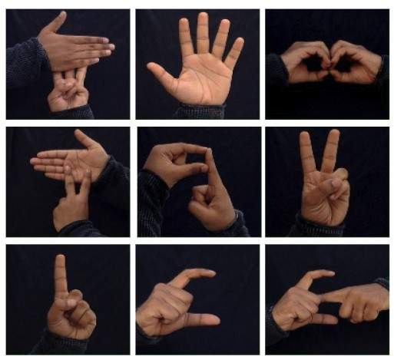
Fig.1. Various Classes of Indian Sign Language
II. LITERATURE SURVEY
In their paper, Ming Jin Cheok, Zaid Omar, Mohamed Hisham Jaward [3] the gesture recognition process can be divided into many stages: data collecting, pre-processing, segmentation, feature extraction, and classification. Static gesture recognition uses single frames of images as input, but dynamic sign languages use video, which uses continuous frames of images as input. The primary distinction between vision-based and sensor-based techniques is the data-acquisition method. This section focuses on the methodology and techniques utilised by vision-based gesture recognition researchers.
In their study, Anup Kumar, Karun Thankachan and Mevin M. Dominic [4] Sign language consists of forming shapes or movements with your hands about your head or other body parts, as well as certain facial cues. A recognition system would thus need to recognise specific head and hand orientations or movements, face expressions, and even body posture.We propose the creation of a simple yet extendable system capable of recognizing static and dynamic movements of American Sign Language, specifically the letters a-z (where j and z are dynamic with hand or fingertip movement while the rest are static). American Sign Language was chosen since it is used by the majority of the disabled.
Ankita Wadhawan and Parteek Kumar [5] CNN's goal is to learn higher-order features in data via convolutions. The CNN design is effective for object recognition, which includes picture recognition. They can recognise individuals, faces, street signs, and other aspects of visual input. There are several CNN versions, but each one is based on the pattern of layers present..CNN architecture is made up of several components such as various types of layers and activation functions. The listing outlines the purpose and operation of various commonly used layers, which are explained further below.Convolutional layer The convolutional layer is the fundamental building element of CNN architecture. Convolutional layers (Conv) use a patch to alter the input data.
Nikolas Adaloglou and Theocharis Chatzis [6] This research presents a comparative experimental evaluation of computer vision-based approaches for sign language recognition. A detailed evaluation of numerous publicly available datasets is performed using the most modern deep neural network approaches in this field. The current study aims to provide insights into sign language recognition by focusing on mapping non-segmented video streams to glosses. Two new sequence training criteria, known from the disciplines of speech and scene text recognition, are introduced for this challenge. Furthermore, a multitude of pretraining strategies are thoroughly covered. To the best of our knowledge, this is the first sign language dataset with three annotation levels (individual gloss, sentence, and overall).
M. Ebrahim Al-Ahdal & Nooritawati Md Tahir [7] Continuous sign recognition is the recognition of phrases or sentences. Its complexity stems from dealing with a stream of gestures that are not physically separated by discontinuity, such as speech words. Many researchers have addressed this challenge and attempted to overcome this limitation.Phoneme modelling is one of several methods for continuous recognition. It is possible to achieve this by assuming that signs can be divided into several smaller units called phonemes or chremes [20] that can be segmented based on changes in movement direction or hand location.
The phonemes are then modelled in a single channel using HMM to make them more like speech. This model has fundamental flaws in that it differs from spoken language in that phonemes appear in sequences, whereas in sign language phonemes appear in random order.
Kirsti Grobel and Marcell Assan [8] Given a set of N states si, we can describe the transitions from state to state at each time step t as a stochastic process. The transition probability to reach state si in the first time step is denoted by q. We call this process a Markov chain if the transition probability aij from state si to state sj depends only on the preceding states. The further assumption that the actual transition is only dependent on the state immediately preceding it results in a first-order Markov chain.We can now define a second stochastic process that produces at each time step t. Symbol vectors x. The emission probability of a vector x is determined solely by the actual state and not by how the state is defined.
Dongxu Li , Cristian Rodriguez Opazo, Xin Yu,and Hongdong Li[9] The Australian National University, Australian Centre for Robotic Vision (ACRV)Similar to action recognition, some recent works use CNNs to extract holistic features from image frames and then use the extracted features for classification. Several approaches first extract body keypoints and then concatenate their locations as a feature vector. The extracted features are then fed into a stacked GRU for sign recognition. These methods demonstrate the effectiveness of using human poses in the word-level sign recognition task. Instead of encoding spatial and temporal information separately, recent works use 3D CNNs to capture spatial-temporal features together. However, these methods have only been tested on small-scale datasets. As a result, the generalisation ability of those methods is unknown. Furthermore, due to the lack of a
standard word-level large-scale sign language dataset.
III.METHODOLOGY

A.Dataset
In the proposed study, a meticulously compiled dataset is presented, which comprises 1780 images distributed across 35 distinct classes, encompassing both numbers and alphabets as per the Indian Sign Language (ISL). The classes are as follows: 1-9: Numerical Digits
A-Z: Alphabets
Each class corresponds to a unique gesture or sign, representing the rich and diverse nature of ISL. The dataset has been designed to capture the nuances of ISL, providing a comprehensive basis for the development and evaluation of advanced image classification algorithms. The goal is to facilitate precise and accurate recognition of ISL gestures, thereby enhancing communication and interaction for the deaf and hard-of-hearing community. The variety and size of the dataset are crucial for ensuring the robustness and effectiveness of the machine learning models trained on it, contributing to the wider accessibility and understanding of Indian Sign Language.
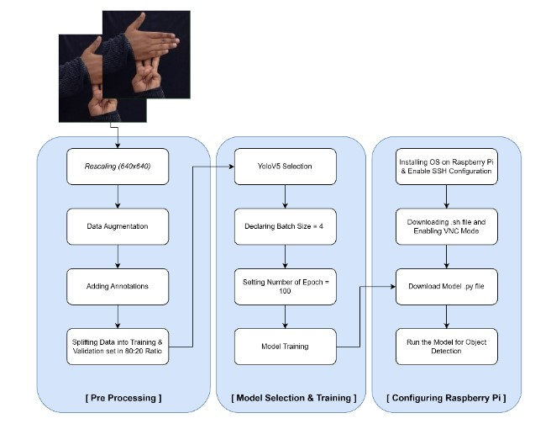
Fig. 2. Proposed flow of the study

A. Preprocessing
Preprocessing datasets comprising Indian Sign Language (ISL) gestures is a crucial step in setting the stage for successful image classification tasks. Typically, an ISL image dataset encompasses a variety of gestures with intricate hand movements and positions, potentially introducing a significant amount of variability and noise. Preprocessing is vital to achieving a consistent visual representation, alignment, and normalization of the images, ensuring that the dataset is primed for accurate gesture recognition and classification.Through the preprocessing phase, the ISL dataset undergoes a series of transformations aimed at establishing a well-structured and standardized set of images. This includes adjusting the image size, enhancing contrast, reducing background noise, and ensuring uniform lighting conditions across all samples. By implementing these preprocessing techniques, we can mitigate the impact of any inconsistencies and variations in the raw images, thereby increasing the reliability and performance of the subsequent object recognition and classification processes. In essence, preprocessing the ISL image dataset is a vital step towards achieving enhanced accuracy and efficiency in gesture recognition, contributing significantly to the overall effectiveness of sign language interpretation systems.

1)Rescaling
Rescaling is inevitably an important process under the domain of preprocessing as it ensures accurate alignment and uniform dimensions of images. In the chosen dataset, Image sizes have been standardised by rescaling them to dimensions of 640 x 640 pixels. This is important since, uniformity in sizes ensures enhanced precision and increases dependability of the detection process. Furthermore, the process of rescaling images has the potential to improve the overall visual validity of the superimposed images through the manipulation of their resolution. This allows for minimizing any visual inconsistencies and a removes any variable maladjustments and promotes a more unified and cohesive alignment.
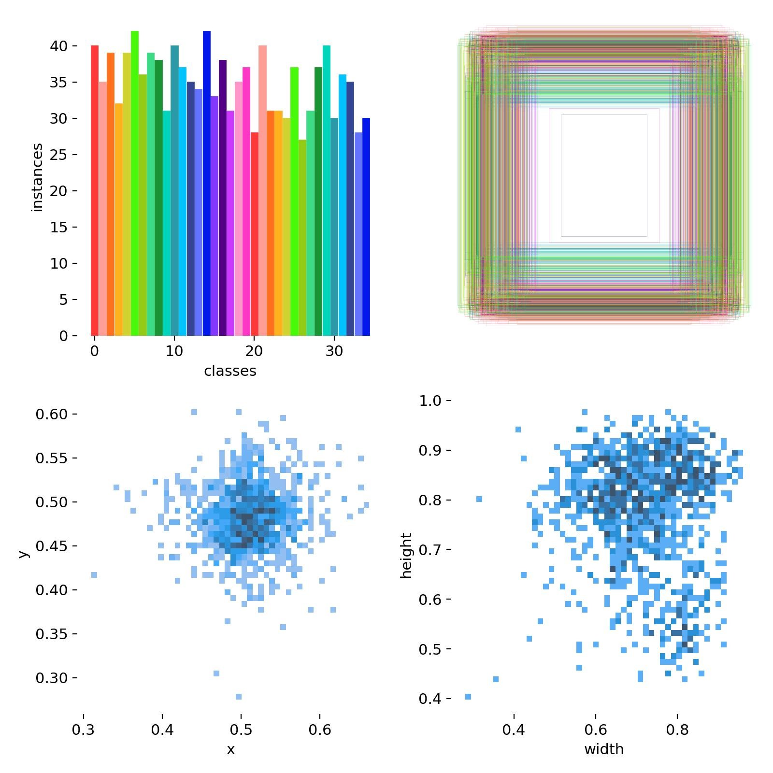
Fig.3. Obtained Class Instances
1)Adding Annotations
Annotations are pivotal in object detection and classification tasks, particularly when it comes to providing crucial ground truth information essential for training machine learning models [10]. In the context of Indian Sign Language (ISL), annotations play a vital role in supervised learning, where each gesture in the images is meticulously labeled, detailing its corresponding class and characteristics.These annotations serve as a guide, helping the machine learning model to learn and understand the visual features associated with different signs and gestures, enabling it to accurately recognize and categorize them when presented with new, unseen datasets. Utilizing tools like Roboflow for the annotation process ensures that the dataset is enriched with varied and precisely labeled data. This, in turn, enhances the model’s predictive capabilities, leading to more accurate and reliable performance in real-world scenarios, especially in recognizing and classifying ISL gestures.Figure 4 illustrates how the ISL dataset is labeled, with each sign and gesture clearly marked and surrounded by bounding boxes, providing a visual representation of the annotation process. This meticulous approach to annotating the dataset ensures that the model is well-equipped to interpret ISL gestures, thereby contributing to improved communication tools for the deaf and hard-of-hearing community.
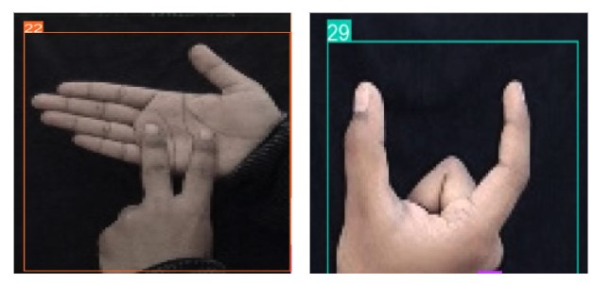
Fig. 4. (a) Class N Labelled Sign, (b) Class U Labelled Sign

C. Model Selection and Training
YOLOv5 was selected as the model for this research due to its effectiveness and efficiency in real-time object detection tasks [11]. Its one-stage architecture and optimized implementation made it well-suited for application on the Raspberry Pi hardware. Fig 5 depicts the Single-Stage
Detector Architecture employed by YOLOv5
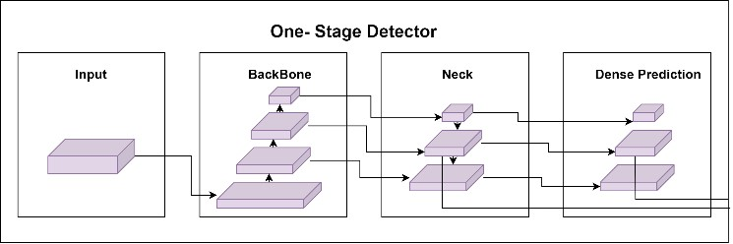
Fig. 5. Single-Stage Detector Architecture
Single-stage object detectors’ architecture are composed of three components: Backbone, Neck and a Head to make dense predictions.
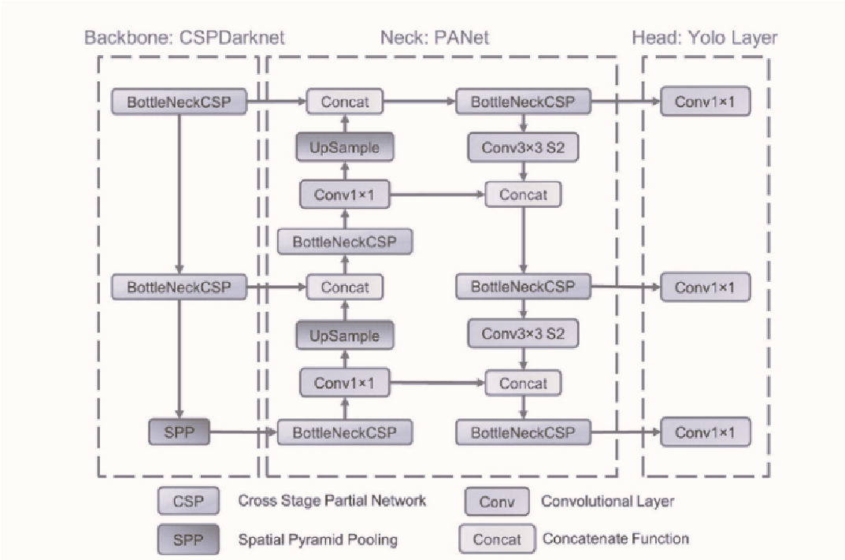
Fig. 6. Network architecture for YOLO v5 [12]
The YOLOv5 models consist of three fundamental components: CSP-Darknet53 serves as the underlying backbone, while SPP and PANet are incorporated in the model's neck. Additionally, the head employed in YOLOv4 is also utilised in these models. Network architecture for YOLO v5 is depicted in detail in Fig6..
- Backbone - CSP-Darknet53: The backbone of YOLOv5 is based on the CSP-Darknet53 architecture, which is an extended version of the Darknet architecture used in YOLOv3. CSP (Cross-Stage Partial connections) improves the flow of information through the network by adding cross-stage connections, reducing computational costs while maintaining high accuracy. The backbone's primary function is to extract rich feature representations from the input image, capturing important visual cues needed for object detection.
- Model Neck: In YOLOv5, the model neck is where additional feature processing takes place to enhance the network's ability to detect objects at various scales and sizes.
The two main components used in the model neck are SPP and PANet.
  - SPP (Spatial Pyramid Pooling): SPP is a pooling technique that It uses different pooling kernel sizes to generate fixed-length feature vectors, regardless of the input size.
  - PANet(Path Aggregation Network): The ability of the model to detect items of various sizes and in congested situations is further enhanced by PANet, which combines feature maps from various scales to generate a thorough feature representation.
- Model Head - The design of the model head in YOLOv5 draws inspiration from the head employed in YOLOv4. The final stage activities in object detection are carried out by this component. The process entails the utilisation of anchor boxes on the feature maps produced by the backbone and the model neck. The primary component then makes a projection of the ultimate outcome, encompassing the categorization of objects, scores indicating the presence of objects, and the precise coordinates of the bounding boxes for every identified object within the image.
The YOLOv5 model underwent training utilising a training dataset, employing a batch size of four. To achieve a trade-off between limitations in GPU memory and expedited convergence during training, a batch size of four was selected. The model underwent training for a total of 100 epochs in order to guarantee convergence and get the highest level of precise accuracy. The determination of the number of epochs was based on empirical evaluation of the model's performance on the validation set. The YOLOv5 model that underwent training possessed the subsequent specifications:
Layers | 157
Parameters | 7023610
Steps per Epoch | 100
Total Training Time (s) | 28800
Time Taken Per Epoch (s) | 288
Time Taken Per Step (s) | 1.82
The dataset was split into two sets: an 80% training set and a
20% validation set. The training set was used to train the model, while the validation set served as an unseen evaluation set to assess the model's performance during training.
The trained model's performance was evaluated on the validation set to assess its accuracy, precision, recall, and other relevant metrics. Confusion matrices and precision-recall curves were analysed to gain insights into the model's classification and detection capabilities

D. Running Model on Raspberry Pi
To deploy the trained YOLOv5 model on the Raspberry Pi, the approach followed a meticulous procedure, considering the hardware's limitations. Initially, VNC (Virtual Network Computing) mode was activated to simplify remote contact with the Raspberry Pi for the purposes of setup and monitoring. After the successful setup of the Raspberry Pi, the camera was engaged to facilitate real-time video streaming. This enabled the model to effectively recognise objects in live feeds. In order to implement the model, the work involved transferring the optimised detect.py file onto the SD card of the Raspberry Pi, so providing smooth accessibility to the inference script. By following the aforementioned procedures, this approach successfully accomplished the proficient implementation and utilisation of the YOLOv5 model on the Raspberry Pi. This has rendered it a very efficient and practical solution for real-world scenarios involving object identification, specifically in the context of arecanut grading. Furthermore, the computational burden associated with this approach has been significantly reduced.
III. RESULTS AND DISCUSSION
The proposed study set out to implement real-time object recognition and classification of Indian Sign Language (ISL) gestures, employing the robust YOLOv5 algorithm on a Raspberry Pi platform. The dataset comprised a diverse collection of images representing 35 different classes of ISL gestures, including numbers 1-9 and alphabets A- Z. Upon completing the training phase with the YOLOv5 model using this dataset, the results were promising and showcased the model’s effectiveness in accurately detecting and classifying ISL gestures. The model achieved a precision score of 0.96061, as illustrated in Fig 7, indicating a high level of accuracy in identifying relevant objects from the dataset.Additionally, the recall rate stood at 0.96594, depicted in Fig 7, highlighting the model’s capability to capture a significant proportion of true positive cases, thus proving its reliability.
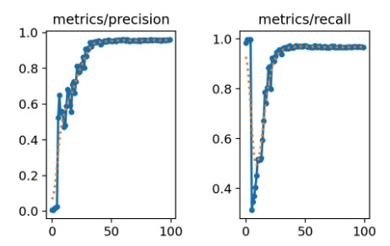
Fig.7. Precision and Recall curve
The model’s proficiency in predicting object positions was evident with a mean Average Precision (mAP) of 0.95837 (Fig 8), showcasing its excellent localization abilities across different classes of ISL gestures.
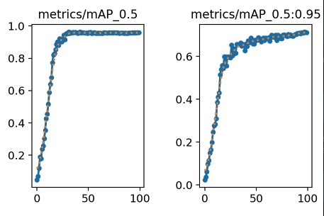
Fig.8. mAP_0.5 and mAP_0.5:0.95 curve
To evaluate the balance between precision and recall, the F1 score was calculated, and at a confidence threshold of 0.23, it was found to be 0.96326. This F1 score confirms the model’s robustness and accuracy, ensuring a balanced trade-off essential for real-time applications.
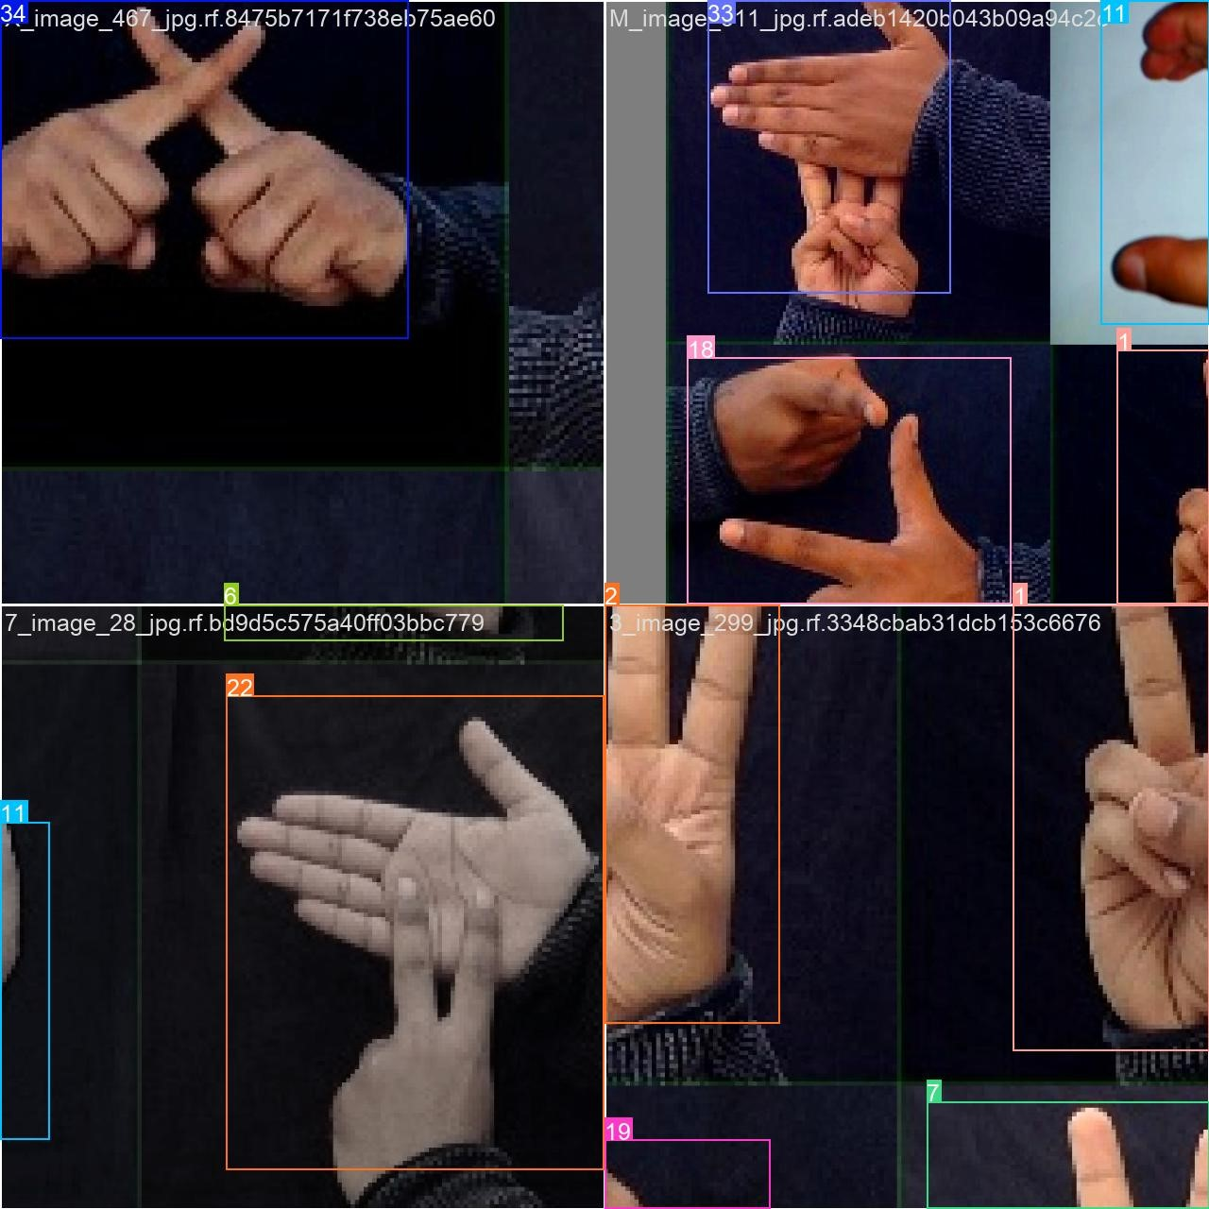
Fig.13.Various Labelled Classes of Indian Sign Languages with Bouding Boxes
Implemented on the Raspberry Pi, the YOLOv5 model demonstrated its real-time capabilities in recognizing and categorizing ISL gestures efficiently, as evidenced in Fig 13. These figures showcase the model’s capacity to label ISL gestures in real time, providing classifications and bounding boxes for each detected gesture. The performance of the model on the Raspberry Pi highlights its potential utility in enhancing communication tools for the deaf and hard-of-hearing community.In summary, the results and discussion underscore the effectiveness of utilizing the YOLOv5 algorithm alongside a Raspberry Pi for real-time recognition and classification of ISL gestures. The high scores achieved in precision, recall, and mAP emphasize the model’s ability to deliver reliable and accurate predictions, even in resource-constrained environments, offering innovative and accessible communication solutions for the deaf and hard-of-hearing community.
However, it is important to verify the calculated F1 score to ensure its accuracy. The F1 score is calculated as 2 *
(precision * recall) / (precision + recall). Using the precision and recall values provided (0.96061 and 0.96594 respectively), the F1 score can be verified as follows:
F1 = 2 * (0.96061 * 0.96594) / (0.96061 + 0.96594) =
0.96326
This calculated F1 score of 0.96326. The calculated F1 score suggests an even higher level of accuracy and balance between precision and recall than initially reported, highlighting the model’s exceptional performance on the ISL dataset.
V. CONCLUSION AND FUTURE WORK
The present study successfully employed the YOLOv5 algorithm on a Raspberry Pi to develop and implement a real-time system tailored for the recognition and categorization of Indian Sign Language (ISL) gestures. The results derived from this methodology showcased impressive performance across key metrics, achieving a precision of 0.96061, a recall of 0.96594, a mean average precision (mAP) of 0.95837, and an F1 score of 0.96326, all evaluated at a confidence threshold of 0.23. These results underscore the model's adeptness at accurately categorizing a variety of ISL gestures into 35 distinct classes, demonstrating a high level of precision.The Raspberry Pi-based model showcased its practicality for real-world implementation, particularly in scenarios with constrained resources. To further enhance user interaction and accessibility, the integration of a graphical user interface (GUI) could be considered. While the proposed method has proven effective, there remains room for improvement and avenues for future research.
A key focus of this study is to expand the dataset to encompass a broader range of gestures and intricate scenarios, aiming to bolster the model's generalization capabilities. Experimenting with advanced data augmentation techniques could also play a pivotal role in elevating the model’s performance. Optimizing hyperparameters and fine-tuning the confidence threshold are additional steps that could contribute to enhanced object detection outcomes.Leveraging transfer learning and cutting-edge architectures in object recognition holds the potential to further refine both the accuracy and efficiency of the system. To ensure the viability of real-time applications in diverse settings, especially those relevant to ISL communication and education, the study also proposes conducting experiments on edge devices with superior computational capacities. Field testing and consultations with experts in sign language education and communication will be crucial in validating the practicality and effectiveness of this approach in real-world scenarios.
In conclusion, this study lays the groundwork for the development of a highly efficient, precise, and accessible technology for ISL gesture detection and classification. Its successful implementation holds the promise of revolutionizing communication aids for the deaf and hard-of-hearing community, contributing significantly to inclusive education and accessibility.
IV. REFERENCES
- B, Shabari & Siddappa, Madappa & Shetty, Surendra & Shetty, Vidyasagar. (2023). Classification of arecanut using machine learning techniques. International Journal of Electrical and Computer Engineering (IJECE). 13. 1914. 10.11591/ijece.v13i2.pp1914-1921.
- Diwan, Tausif et al. “Object detection using YOLO: challenges, architectural successors, datasets and applications.” Multimedia tools and applications vol. 82,6 (2023): 9243-9275. doi:10.1007/s11042-022-13644-y
- A review of hand gesture and sign language recognition techniques Ming Jin Cheok, Zaid Omar and Mohamed Hisham Jaward
- Sign Language Recognition Anup Kumar, Karun Thankachan and
Mevin M. Dominic
- Deep learning-based sign language recognition system for static signs Ankita Wadhawan and Parteek Kumar
- A Comprehensive Study on Deep Learning-Based Methods for Sign Language Recognition Nikolas Adaloglou , Theocharis Chatzis
- Review in Sign Language Recognition Systems M. Ebrahim Al-Ahdal & Nooritawati Md Tahir
- Isolated Sign Language Recognition using Hidden Markov Models Kirsti Grobel and Marcel1 Assan
- Word-level Deep Sign Language Recognition from Video: A New
Large-scale Dataset and Methods Comparison Dongxu Li , Cristian Rodriguez Opazo, Xin Yu, Hongdong Li The Australian National University, Australian Centre for Robotic Vision (ACRV).
- Rasmussen, Christoffer Bøgelund et al. “The Challenge of Data
Annotation in Deep Learning-A Case Study on Whole Plant Corn Silage.” Sensors (Basel, Switzerland) vol. 22,4 1596. 18 Feb. 2022, doi:10.3390/s22041596
- Redmon, J., Divvala, S., Girshick, R., & Farhadi, A. (2015). You Only Look Once: Unified, Real-Time Object Detection. ArXiv. /abs/1506.02640
- YOLO v5 model architecture [Explained]. [Online] Available: https://iq.opengenus.org/yolov5/; Last Accessed date: 26/07/2023

